1. CSS clip path maker  
     
   <https://bennettfeely.com/clippy/>  
     
   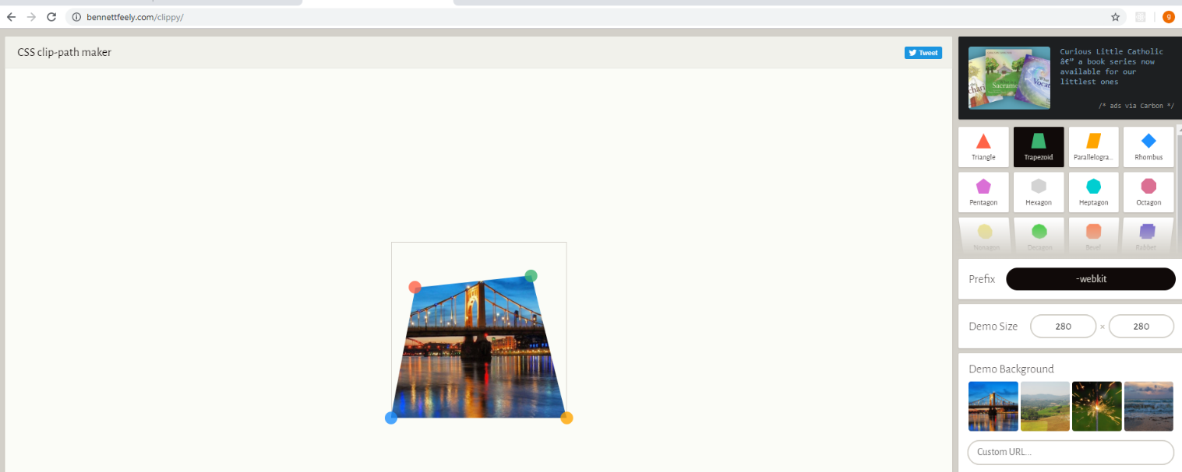  
     
   
2. Emmet.

Allows us to write html faster.

1. <https://css-tricks.com/snippets/html/glyphs/>  
   HTML code to show symbols in the webpage. For example an arrow / copyright symbol etc
2. Icon font.

* Linea

1. Nice images :

unsplash